**12-659**

**SPECIAL TOPICS: MATLAB**

**Exercise 2**

**Name: Yuhang Liang Andrew ID: yuhangl**

**October 29, 2019**

Question 1

According to the question, we create a 5x3 matrix of sevens first. As shown in Figure.1.

Figure.1. Answer to Question1

1. For this question, I created the target matrix in Matlab. The following screenshot is my answer.

Figure.2. Answer to Question1(a)

1. For this question, I created the target matrix in Matlab. The following screenshot is my answer.

Figure.3. Answer to Question1(b)

1. For this question, I created the target matrix in Matlab. The following screenshot is my answer.

Figure.4. Answer to Question1(c)

Question 2

The target images I created in Matlab are shown below.

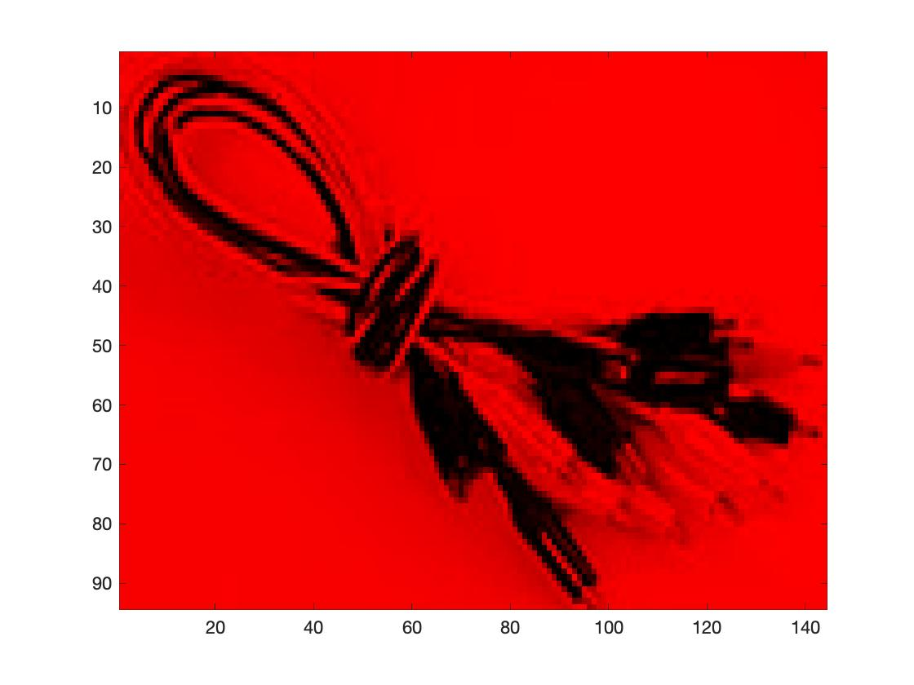 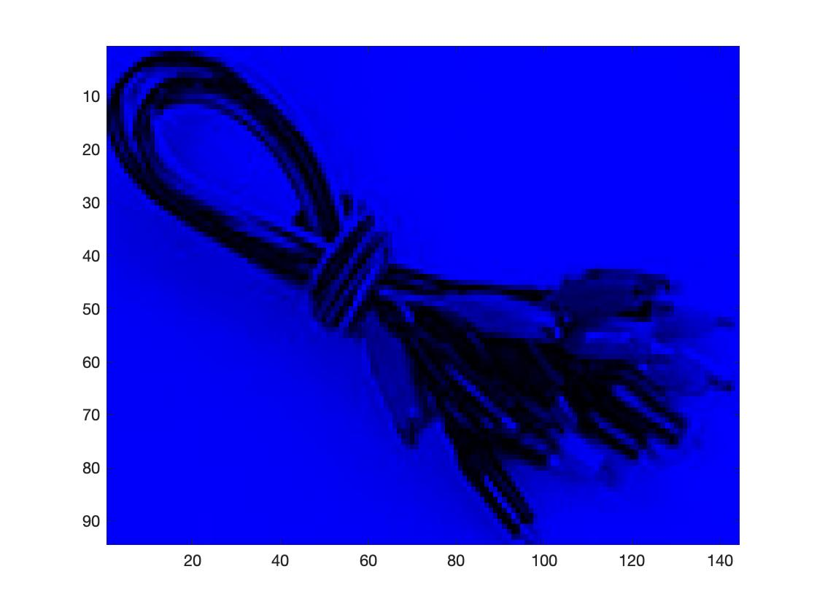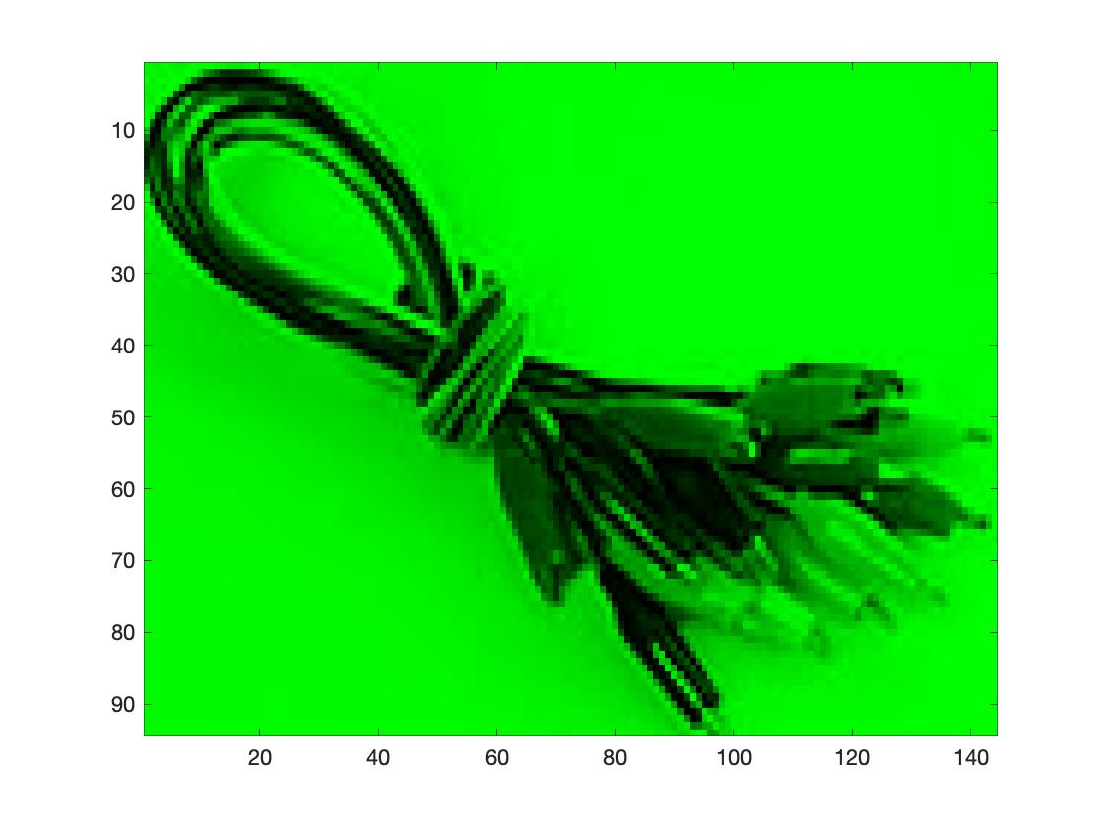

Figure.5. Answer to Question2

Question 3

The target images I created in Matlab are shown below.

Figure.6. Answer to Question3

Question 4

The resulting image I created in Matlab is displayed below. And the site of the stop position is at row 5, column 12.

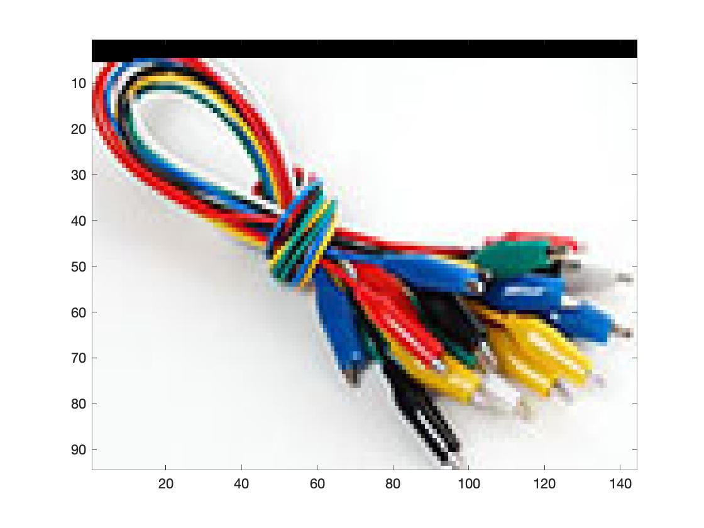

Figure.7. Answer to Question4

Question 5

The resulting code is in ‘Exercise2_code_yuhangl.m’.